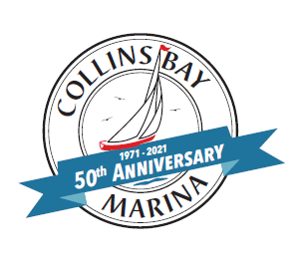HARBOUR VIEWS
COLLINS BAY MARINA NEWSLETTER 50TH YEAR - 2021

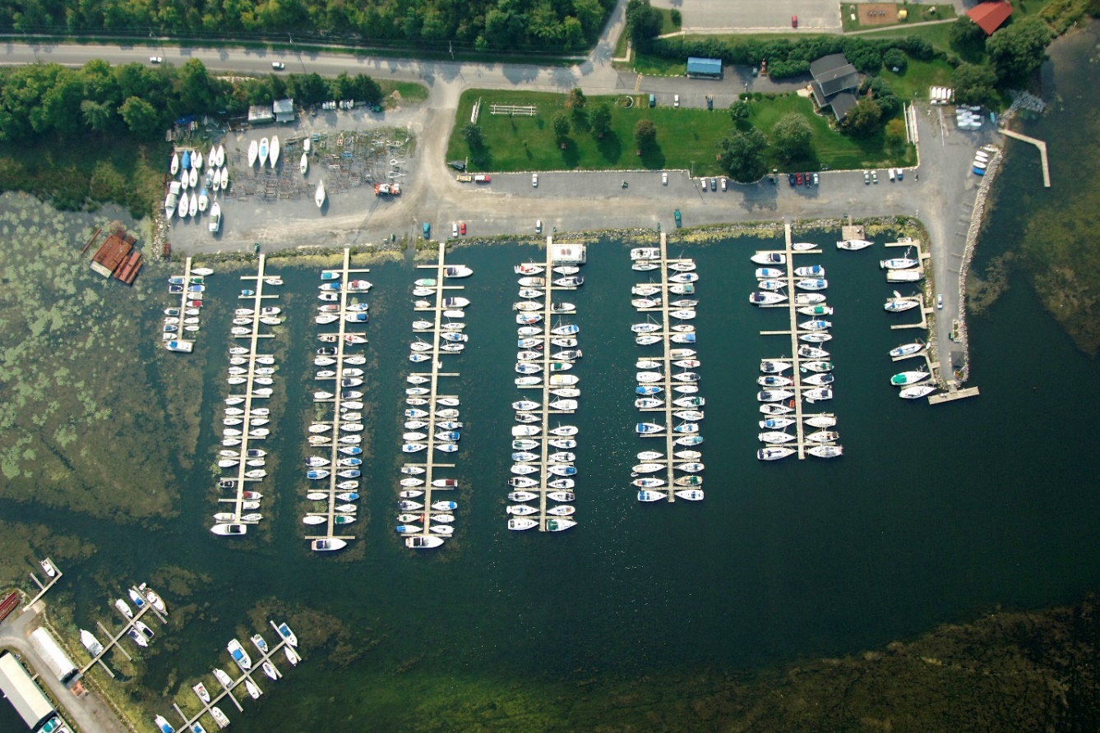

ANNIVERSARIES
We are excited to announce the marina’s 50th anniversary 1971-2021 as well as our 10th anniversary 2011-2021 as the marina owners! It is an honour to recognize the continued success after 50 years!
We hope to be able to celebrate this milestone with all of you soon, stay tuned for more details

COLLINS BAY MARINA 1971
In 1965 Bill and Maria Steenbakker purchased 18 acres of waterfront property that was a farmhouse, used as a cottage and is now the current office and home.
In 1971 13 acres were sold off to develop the marina, with 13 slips the first year in the 14 – 18’ size with the largest boat being 22’, all on docks with Styrofoam floats. Within 5 years there were 150 slips.
In 1980 Collins Bay Yacht Club was formed, which is a vibrant social group of CBM boaters.
In 1986 Hub Steenbakker took over the day to day operations of the marina designing and building new docks, dredging and modernizing the marina.
In 2011, the Buzzi family purchased the marina from Maria and Hub Steenbakker and continue to operate it today with 304 slips, beautifully manicured grounds, immaculate washrooms and custom designed and in house built and maintained docks.
The marina is thriving with a robust community of power and sailboats who gravitate to the amazing destinations in our vicinity which truly is a boater’s paradise.
Since the beginning, Collins Bay Marina has always strived and is determined to provide exceptional service and outstanding facilities to enhance our boaters experience on the water; as well as preserving the beauty of our natural surroundings.
We are proud to celebrate the last 50 years and look forward to many more years of memorable moments with dedicated, professional service for our community at Collins Bay.
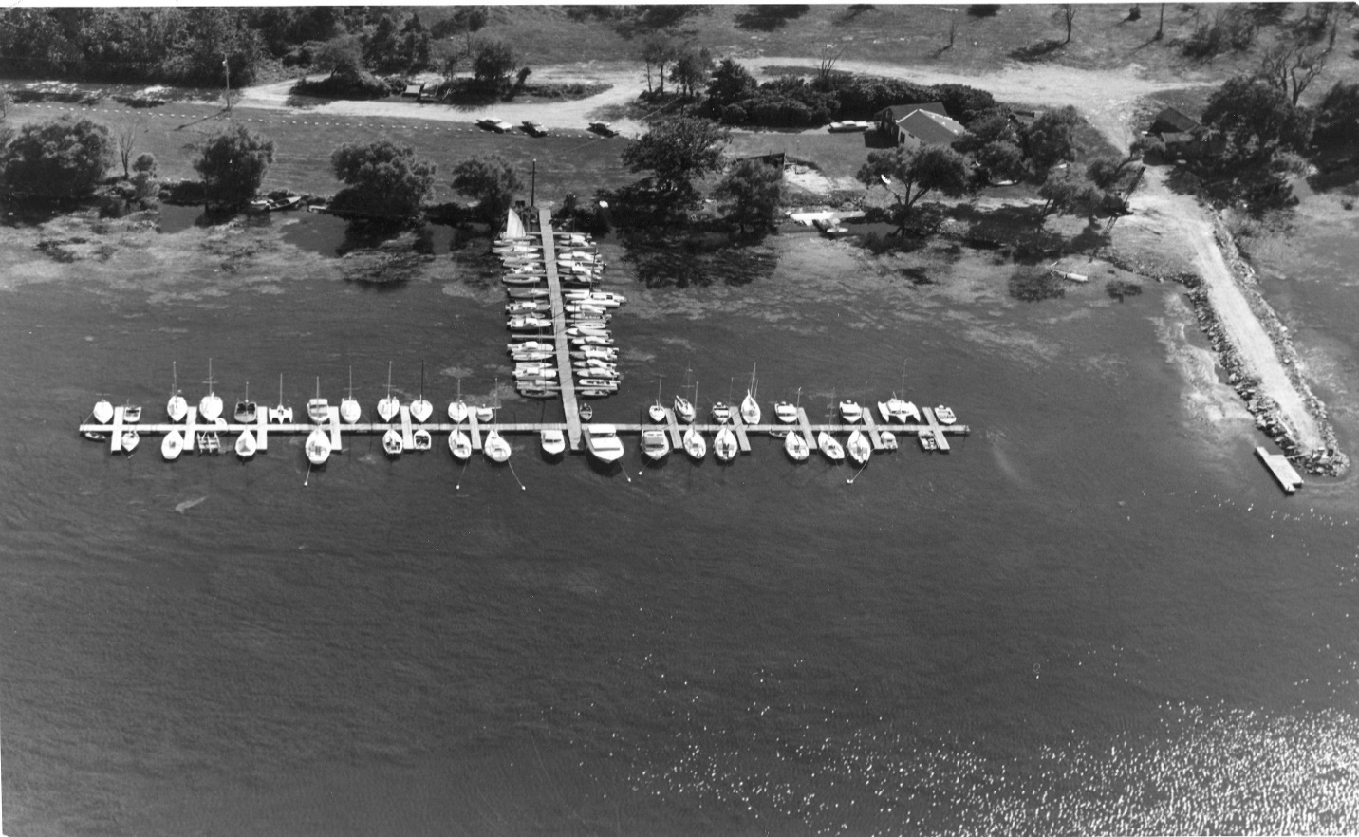
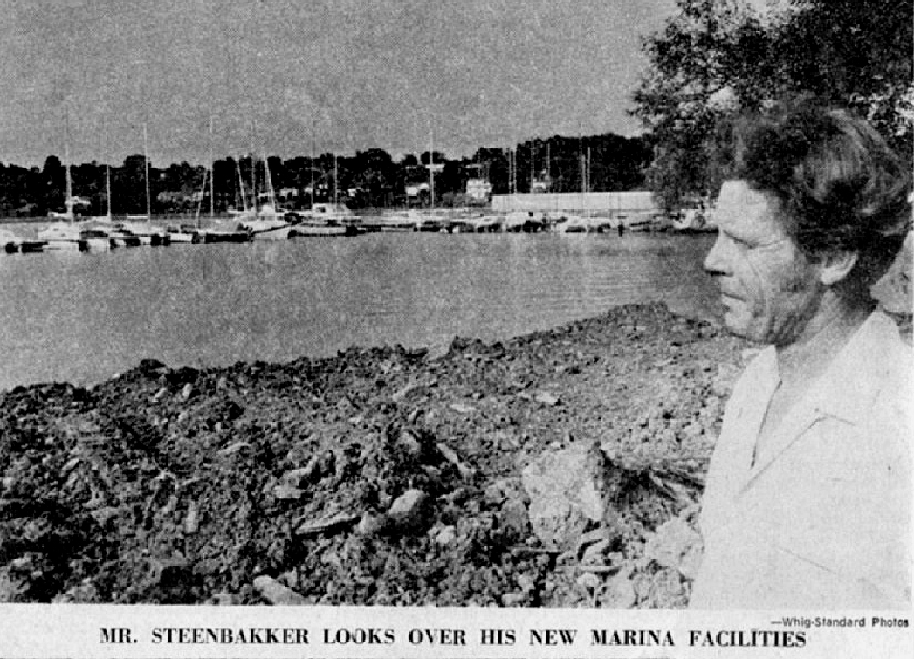

PHOTO CONTEST
To celebrate Collins Bay Marina’s 50th anniversary, we are asking for you to submit your memorable photos-past or current of your time at the marina or on the water in Collins Bay!
Submit to info@CollinsBayMarina.com

CMM – CERTIFIED MARINA MANAGER
We are pleased to announce that Lori has achieved the CMM-Certified Marina Management designation from the highly respected Association of Marina Industries. Lori is the 2nd female in Ontario and the 11th worldwide to hold this esteemed designation!

INSURANCE AND OUTSIDE CONTRACTORS
It is a mandatory requirement by the marina to have current insurance by all boat owners. Please make sure to send this information with your summer confirmation renewal as we require this before launch and for the 2021 upcoming season. All outside contractors must also have insurance and WSIB to be able to work onsite at the marina. If you are looking for a contractor, we may be able to assist with a recommendation. If you have a contractor that you would like to use, please make sure they contact the office before working on your boat.
Please note that unattended use of power in the winter is prohibited. It is a serious fire hazard and will void your boat insurance policy.
TORONTO INTERNATIONAL BOAT SHOW
Although we are not able to provide tickets this year as the show is cancelled due to Covid, you can still attend the boat show virtually January 18 -24, 2021! We look forward to providing tickets to attend the show in 2022!
ENVIRONMENTAL POLICIES
The marina is passionate about a clean environment for all. It is essential to the enjoyment of boating. Please help us protect the environment.
We provide recycling totes for cans, plastic, glass and cardboard. Please use these totes and place your folded, compacted and clean recyclables here instead of in the garbage. We also have a cigarette butt disposal container at the washroom building as cigarette butts do not break down. We ask that you not throw butts on the ground or into the water.
Please cover the ground under your boat while doing any work to the hull or exterior. Thank you for protecting the ground, water and landscaping from any contamination.
Did you know we also recycle used oil, antifreeze, marine and household batteries? We just ask that you hand it to any one of our great staff to prevent any spills and we will dispose of it safely in our containment area.
We appreciate your help to protect our waterways and environment and for committing to our Clean Marine Pledge.
COLLINS BAY YACHT CLUB
Collins Bay Yacht Club is a vibrant social community of active sail and power boaters within Collins Bay Marina. The club has a strong foundation of camaraderie and organizes many activities both on and off the water year round. They also operate a first class sail training for youth and adults. The club has much to offer for a nominal membership fee.
For more information check out their website: http://collinsbaymarina.com/cbyc/ We are looking forward to seeing you at these activities, however they may be able to safely happen this season!
SURVEY
We have recently emailed a survey to everyone to help us discover your interests and wants for both the marina and the yacht club. Please take a few minutes to answer these questions and if you didn’t receive it in your inbox please email the office.
We look forward to gathering this information to help us provide the best facility! Thank you for your time completing this!

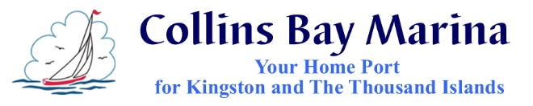
Gerry and Lori Buzzi
1270 Coverdale Drive, Kingston ON K7M 8X7
www.CollinsBayMarina.com
(888)-748-5557 (613) 389-4455

